INNOVATIVE FINANCE MECHANISMS FOR PROTECTED AREAS:
roadmap and next steps for piloting selected SFMs in the target PAs
Report to UNDP-GEF “Sustainability of Protected Areas (SPA)” project
Lucy Emerton, 4 June 2024

Table of contents
1 Introduction & aims 1
2 Summary of the prioritisation process 2
2.1 Preliminary screening of finance needs and potential 2
2.2 Shortlisting and selection of SFMs to take forward 2
2.3 Proposed pilot mechanisms and sites 3
3 Description and examples of the selected SFMs 4
3.1 Cost recovery-linked PA recreation fees 4
3.2 Surcharges for nature through road tolls & bednight levies 6
3.3 Nature-themed branding, labelling & sponsorship 8
3.4 Building a business case for flood control payments to PH Tišina 11
4 Key steps, results, and modalities for delivery 15
4.1 Cost recovery-linked PA recreation fees 15
4.2 Surcharges for nature through road tolls & bednight levies 16
4.3 Nature-themed branding, labelling & sponsorship 18
4.4 Building a business case for flood control payments to PH Tišina 19
4.5 Cross-cutting needs, capacity requirements & enabling conditions 21
5 Consolidated roadmap for moving forward 23
6 References 26

List of figures
Figure 1: SFMs with ‘in principle’ potential for further development in BiH 2
Figure 2: Shortlist of SFM options for possible development under the project 3
Figure 3: Cost recovery benefit tiers for Pleasant Valley Recreation and Parks District 5
Figure 4: Key steps, milestones and targets in developing the pilot SFMs 23
Figure 5: Key participants, roles and responsibilities in delivering milestones 24

List of abbreviations & acronyms
BiH | Bosnia and Herzegovina
CESR | Corporate environmental and social responsibility
KM | Convertible Mark (at the time of writing the report, EUR 1 = approx. KM 1.96)
METT | Protected Area Management Effectiveness Tracking Tool
NGO | Non-governmental organisation
NM | Natural Monument
NP | National Park
PA | Protected area
PES | Payments for ecosystem services
PH | Protected Habitat
PL | Protected Landscape
PN | Park of Nature
PPP | Public-private partnership
SFM | Sustainable finance mechanism
SPA | Sustainability of Protected Areas project
UNDP | United Nations Development Programme

Introduction & aims
The Sustainability of Protected Areas (SPA) project seeks to achieve practical improvements in the management of protected areas (PAs) in Bosnia and Herzegovina (BiH) and to ensure better biodiversity status, through strengthening resilience to the impacts of climate change and enhancing financial sustainability. It is working in 10 target sites in the Federation of Bosnia and Herzegovina and Republika Srpska, including Category II National Parks (NPs), Category IIIa Parks of Nature (PNs), Category IIIb Natural Monuments (NMs), Category IV Protected Habitats (PHs) and Category Va Protected Landscapes (PLs).

The second component of the project is concerned with improving the financial sustainability of the target PAs, including through the development of sustainable tourism, cooperation with the private sector, participation in government grant programmes, and promotion of PA natural values, products and services. To these ends, a variety of innovative sustainable finance mechanisms (SFMs) are envisaged to be identified and piloted under the project. These intend to reduce the current funding gap, bring in new elements of PA finance, and recommend and test improved financial models.

This report is the third of six deliverable outputs on PA finance. It describes each of the proposed SFM pilots, lays out key activities, outputs, milestones and a timeline for developing these, as well as identifying additional information, technical and other enabling conditions that may be required to roll out the new finance mechanisms.

Summary of the prioritisation process

Preliminary screening of finance needs and potential
Between November 2023 and February 2024, a scoping exercise was carried out to assess needs and opportunities for developing SFMs in the target PAs. This screened conservation finance mechanisms that are commonly used in other parts of the world according to their relevance and feasibility to the BiH context and the situation of the target PAs. A shortlist of SFM options that might be taken forward by the SPA project was compiled. Consultations were carried out with the target PAs, other experts and stakeholders, and 1a review of relevant literature and statistics was undertaken. The scoping exercise is documented in the February 2024 report “Innovative finance mechanisms for protected areas: recommendations on the further development of PA sustainable finance mechanisms”.

Fourteen finance mechanisms were identified as having ‘in principle’ potential for further development in the target PAs (Figure 1). These were grouped into three categories, according to what could be accomplished within the project timeframe, budget and other available resources: those that can be readily initiated and demonstrated for wider replication; those for which concepts can be developed, with a view to identifying opportunities to collaborate with another partner to jointly pilot a new finance mechanism; and those for which efforts can be made to build awareness, capacity and the business case for future uptake.

Figure 1: SFMs with ‘in principle’ potential for further development in BiH
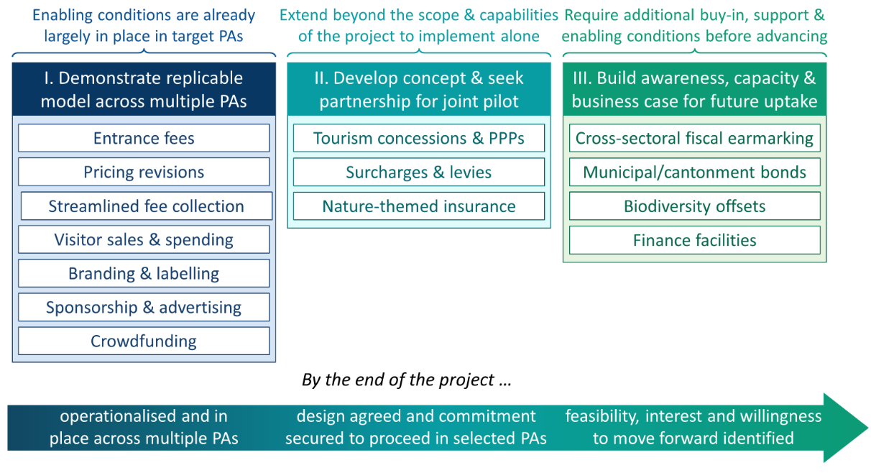

Shortlisting and selection of SFMs to take forward
Based on this screening, a shortlist of possible SFM pilots was developed. This was intended to serve as the basis for further discussions, and to guide the selection of pilots. Seven SFM options were shortlisted, tailored to the specific needs, circumstances and capacities of the target PAs (Figure 2). These were: A. establishment and/or revision of PA fees and charges; B. streamlined fee collection systems; C. road tolls, bednight levies and other nature-oriented surcharges; D. branding, labelling, sponsorship and advertising; E. contributions from the general public through in -PA spending and remote campaign; F. nature -themed insurance policies; G. business case and advocacy for additional SFMs, including public finance instruments (e.g. fiscal earmarking, park bonds), market -based instruments (e.g. payments for ecosystem services, biodiversity credits), and those involving the private sector as lead participants (e.g. biodiversity offsets, results -based payments or ‘pay for success’, finance facilities).

Figure 2: Shortlist of SFM options for possible development under the project
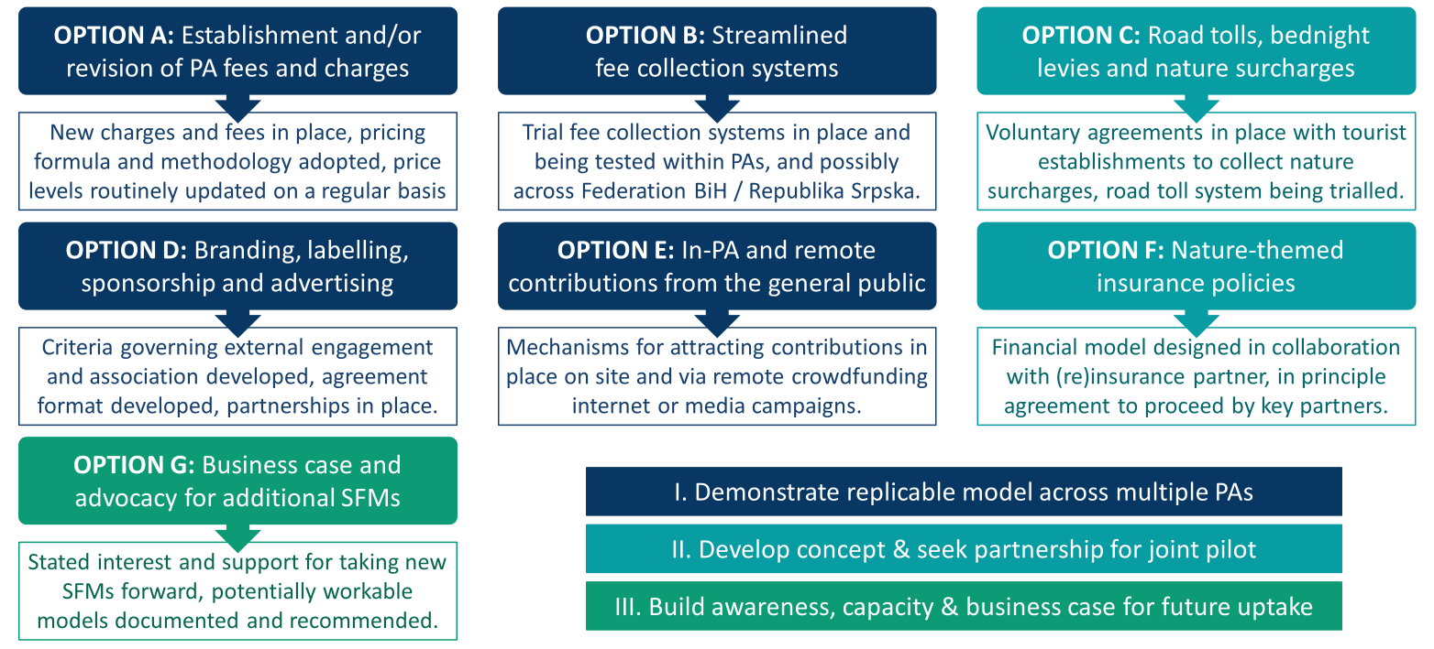

The selection of pilot SFMs was validated, elaborated and finalised during a 3-day workshop and consultation with managers and other staff from the target PAs as well as representatives of the Ministry of Environment and Tourism of the Federation of Bosnia and Herzegovina and the Ministry of Spatial Planning, Construction, and Ecology of the Republic of Srpska. Participants prioritised SFMs for further development, and expressed their interest in piloting these.

The workshop proceedings and conclusions are documented in the May 2024 report “Workshop report: strategic approaches and practical tools for the sustainable financing of protected areas (April 23-25 2024, Neum)”.

Proposed pilot mechanisms and sites
Four SFMs were prioritised for further development under the project, based on options A, C, D and F/G in the shortlist. These are:
- Establishment and/or revision of PA fees and charges based on cost recovery principles;
- Introduction of nature surcharges through road tolls and bednight levies;
- Application of nature-themed branding, labelling and sponsorship to key products and service that depend on PA goods and services; and
- In addition, interest was expressed in the idea of using PH Tišina as a model example from which to build a business case for nature-themed insurance and/or payment for ecosystem services. This would also provide a means of linking PA sustainable finance to biodiversity and ecosystem valuation, a topic which had been presented in the opening session and had generated a lot of interest among participants.

Description and examples of the selected SFMs

Cost recovery-linked PA recreation fees

Rationale
Recreational and tourist services in PAs are often underpriced as compared to visitors’ willingness to pay, relative to comparable offerings elsewhere, and in terms of the costs of establishing and maintaining the staff capacities, facilities, equipment and infrastructure that are required to provide those services. Furthermore, prices are often not updated on a regular basis, and do not keep pace with inflation.

As a result, revenues are not optimised. In some cases, PA recreation and tourist facilities may even be running at a loss, or diverting scarce funding away from core conservation priorities. There is no reason why PAs should subsidise the provision of facilities and services that could and should be run on a commercial basis, and/or are being provided to commercial users. Equally, recreation and tourism should not compete for funding with conservation. Under-pricing may even undermine conservation goals, if it encourages levels and types of use that overreach the PA’s ecological carrying capacity or exceed safe or sustainable use levels for particular facilities, services or infrastructure.

Applying cost recovery principles can help to avoid these financing risks. It is also a way of rationalising and optimising PA revenues. It should however be noted that ‘optimisation’ does not always equate to profit maximisation. Not all recreation and tourist services should be seen as commercial ventures, or be subject to profit-maximisation goals. There may be other optimisation goals when deciding pricing levels, such as education, awareness, access, public amenity, safeguarding cultural heritage, or encouraging local uses and users. In these cases, different principles apply regarding cost recovery.

Purpose and aims
The purpose is to develop, demonstrate and test a standardised methodology for pricing recreational and tourism facilities, with a view to increasing revenues and improving cost recovery.

This SFM aims to:
- Self-finance the direct and indirect costs of providing key recreation products, services and facilities;
- Ensure that fees are set at realistic levels, that are appropriate to the type of use and user; and/or
- Help to manage demand and maintain use at optimal levels, including encouraging or minimising visitation rates for particular sites, services, facilities and/or user groups.

Case study example(s) of how this mechanism has been applied to fund conservation
It is now commonplace for PAs to incorporate cost-recovery principles into their pricing formulae. In Canada, for example, charges for PA services and facilities have long been set at market rates, with a considerable degree of flexibility allowed for prices to be determined at the site level, reflecting the real costs of provision in that place, as well as consumer demand, and ecological values (LeRoy and Green 2005). Canada’s 2017 Service Fees Act also allows for automatic annual fee adjustment in line with the consumer price index, so as to ensure that fees keep pace with inflation. Similar principles are applied in the USA, and have had a demonstrable impact on the level of revenues collected. For example, after concession fees (for tourist lodging, transportation, meals and recreation) and charges for park entry, camping and other amenities were adjusted for cost-recovery and inflation, the US National Parks Service’s income increased by 39% (GAO 2015).

Most parks and protected areas in the USA use a sliding scale to determine recreation fees, where the cost recovery target varies depending on the type of use and users involved. These usually differentiate between commercial and social users and uses. For example, in Colorado, Boulder Parks and Recreation Fee Policy establishes a scale of variable cost recovery rates, aiming to create a standard approach for all fees collected, develop transparent fee categories, and impose clear cost recovery targets (City of Boulder 2024). First of all, the demand and market rates for different activities are evaluated (so as to determine price sensitivity), next options to reduce costs are considered, and then finally the rate is set.

The cost recovery calculations take account of both direct and indirect costs. Direct costs include those specifically and exclusively related to providing a specific service (e.g. staff time, materials and supplies). Indirect costs are those incurred across the Parks Department that are not directly attributed to a specific service, but are incurred by the parks management as a whole (e.g. marketing expenses, software, utilities, rent and general management staff that support a variety of services or programs). Both the fees and the cost recovery rates are reviewed at least every two years, as part of the annual budget development process. To minimise any negative impacts or opposition from recreational users and the tourism industry, fee increases are limited to 10% a year, and new fees or higher rates are often phased in over a 2-to-3-year period

The cost-recovery rates range from a minimum of 0% for community access to parks, park amenities, pathways and natural areas, up to 100% for purely commercial sales of food and equipment, large-scale organised races and competitive sports events, and exclusive rental of space or facilities by one person or group. Other uses and users are subject to cost recovery rates somewhere in between these two extremes. For example, a rate of 10% is imposed on events that appeal to a broad portion of the community (such as snow fun days or holiday food markets), while 70% is applied for sports classes and coaching that charge a fee for participation.

In order to apply this cost recovery methodology, it is necessary to categorise every recreational service, product or facility offered into a programme type. Each programme type is then allocated a minimum and a target cost recovery rate. For example, California’s Pleasant Valley Recreation and Parks District categorises park beneficiaries and uses into six tiers (Figure 3), ranging from community-wide benefit (0% cost recovery) to exclusively individual benefit (100%). Using a similar methodology to that applied by Boulder Parks and Recreation, it bases prices on cost of service analyses, looking at park performance, market conditions and other factors (ClearSource 2022). These are reviewed on a regular basis. Any revisions in fees or cost recovery rates must then be submitted to the Parks Board for consideration and approval.
Figure 3: Cost recovery benefit tiers for
Pleasant Valley Recreation and Parks District
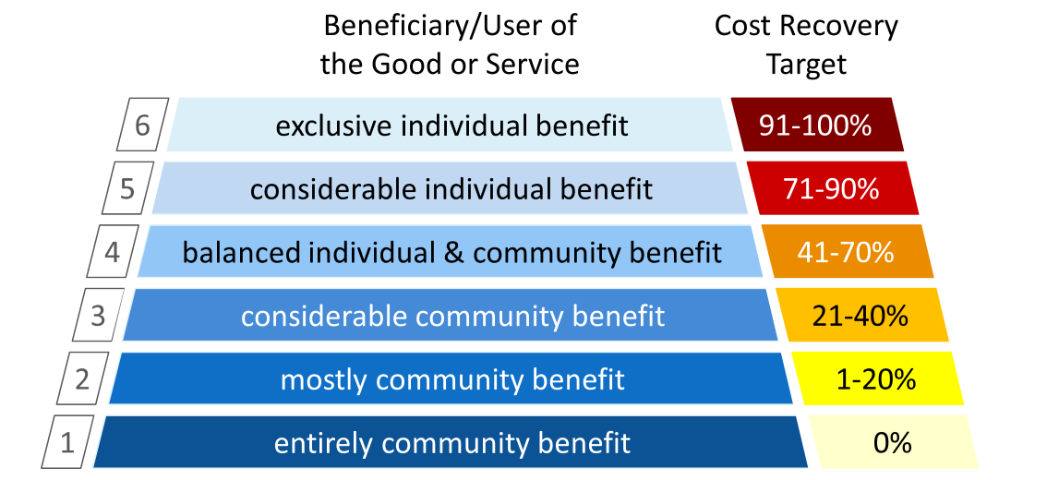
From ClearSource 2022.

Model for the SFM pilot
A standardised pricing methodology will be developed, applied, and updated on a regular basis. This will be kept as simple as possible, so as to allow for prices to be easily calculated and periodically reviewed, and for the basis for pricing to be clearly and transparently communicated to PA users and the tourism industry.

The pricing methodology will focus only on major recreational uses and activities (although may at a later date be scaled up to other activities, such as resource harvesting). These may for example include entrance fees, visits to historical and natural sites, use of hiking or biking trails, trains or cable cars, campsites, other accommodation, parking facilities, and holding sporting and other special events. The formula applied will seek to recoup an agreed proportion of the costs of providing each category of goods, services and facilities, with the exact cost recovery target depending on the type of use and user that is involved.

While the same methodology would be applied consistently across all participating sites, it would allow each PA the flexibility to set its own goals for cost recovery, and to determine how its services, facilities and users would be categorised (and thus priced). Ideally there would be coordination between different sites when determining cost recovery categories and targets, so as not to result in massive disparities between PAs. Efforts should also be made to determine user numbers and carrying capacity, investigate consumer willingness to pay for PA services and facilities, and to assess the possible impacts of pricing on the demand for PA services and facilities. As far as possible, key PA users and representatives of the tourism industry should participate in the process of developing the methodology.

Surcharges for nature through road tolls & bednight levies

Rationale
Many PA goods and services do not have a market or price, and/or cannot be directly charged for. This tends to particularly be the case for non-consumptive benefits or indirect services that contribute towards production, consumption or income generation in other sectors – for example the landscape beauty and natural assets that enable and encourage tourism, provision of space for travel and transit, reproduction and replenishment of stocks of natural products, or maintenance of the microclimatic conditions and pollinator populations that uphold agricultural production.

Even when it is not legally or practically possible for the PA to collect direct fees or charges for these services, there may be opportunities to capture revenues through consumers’ spending on other, linked products. Examples include introducing a surcharge on road access or hotel stays. A surcharge is an extra fee added on to the usual price of goods or services. Unlike a tax (which is always mandatory, and is directly imposed and collected by government), it is usually levied by the producer or retailer of that good or service, and is paid by customers and consumers.

In some cases nature surcharges may be compulsory. This is often the case where products run the risk of harming biodiversity and ecosystems, or require some kind of remediation or clean-up (for example garbage disposal or road maintenance). Buyers or users of goods and services can also be requested to pay surcharges on a voluntary basis. Voluntary surcharges usually tap into consumers’ personal interest in biodiversity and ecosystems, and their willingness to contribute to conservation (for example payment of an extra fee on top of their hotel or restaurant bills, opting in to offsetting the carbon footprint of flights).

Purpose and aims
The purpose is to introduce nature surcharges and levies for road users and visitors to hotels located within or close to PAs, so as to expand and diversify PA revenue sources.

This SFM aims to:
- Charge for the non-consumptive benefits or indirect services provided by PAs to the road transport and tourism sectors; and/or
- Better capture the general public’s interest in and willingness to contribute to nature conservation.

Case study example(s) of how this mechanism has been applied to fund conservation
A variety of surcharges are used around the world to fund conservation. Transportation tolls, air passenger charges and hotel levies are among the most commonly used. This is largely because these are easy and cheap to implement, and tap into a largely captive market of consumers that are already paying for a service, and are likely to be willing to absorb a small additional premium for conservation.

For example, in the USA, a road toll is charged to all motorists using a 125 km scenic highway in Florida known as ‘Alligator Alley’ (the Everglades Parkway, a section of the I75), where there is a good chance of spotting alligators and other wild animals and birds. The road goes through Big Cypress National Preserve, and skirts the Everglades National Park. The toll is calculated as a fixed rate, based on vehicle axle weight and distance travelled, and ranges between USD 2.94-3.24 for cars and USD 5.88-22.75 for trucks. It can be paid by cash, via mailed invoices based on license plate recognition, or through an electronic pass (which gives a discount). The toll raises more than USD 60 million in revenues each year, part of which goes to conservation of the Everglades ecosystem, and is used to restore habitats lost to road construction.

Along similar lines, a road toll of USD 70 is charged to vehicles transiting through Ngorongoro Conservation Area on the B44 road in Tanzania, which connects the major city of Arusha with the Serengeti National Park, Lake Victoria and the Kenya border. This is separate to any entry charges to the PA or fees for tourist facilities, and is valid for 24 hours. Surcharges are also levied on the hotel bills of tourists staying in Tanzania’s National Parks. Overnight visitors are required to pay a ‘concession’ fee, applicable to all permanent facilities within the national parks. The fee ranges between USD 10 and 60 per person per night. The proceeds accrue as revenues to the Tanzania National Parks Authority. Many hotels in and around government-run protected areas and private/community conservancies in Kenya also charge voluntary or mandatory bednight levies on top of hotel bills. These are used to fund local conservation activities or paid into a site-level conservation trust fund.

Bednight levies or tourist surcharges may also be applied at the national level. For example, in August 2023, a mandatory Tourism Environmental Sustainability Levy (known as the ‘eco-levy’) was introduced in the Seychelles. Charged on a bednight basis, this is added onto guests’ bills, and collected directly by the accommodation facility. It is applicable to all hotels, guesthouses, cruise ships and yachts. Rates range between USD 2-8, and are lower for smaller establishments and higher for large hotels and resorts. The proceeds are to be spent directly on conservation and ecosystem restoration initiatives. In Belize, a variety of conservation levies and surcharges are charged, most of which are embedded in other fees. For example, the Belize Protected Area Conservation Trust is funded from a conservation fee of USD 3.75 charged as part of the larger international airport or seaport departure tax, a 15% commission on cruise ship passenger fees, and transit fees charged to yachts sailing through marine protected areas (ranging from USD 5 to USD 10 per person).

Model for the SFM pilot
Nature tolls or transit fees would be introduced for major roads that pass through or run alongside PAs, and bednight levies established in hotels that are located in or close to PAs, or host nature tourists. In order to avoid any possible legal challenges or conflicts of interest/authority with other agencies, these would be introduced on a voluntary basis, at least initially.

Hotel levies would simply be added onto people’s accommodation bills, allowing guests to opt out if they do not wish to pay. These could be charged as a flat fee or percentage of the bill, on a bednight basis or as a one-off payment for the entire stay. Road tolls or transit fees may be slightly more complicated to collect, except for pre-existing toll roads or for roads that pass by a PA entry gate or ticket booth. While the rates and methods of fee collection would likely vary between different PA sites, the amount charged should be kept to a minimum. Both road tolls and hotel levies should be understood as small, token contributions to nature conservation, not as fee systems that could potentially distort prices or substantially increase the cost of travel and transport.

Clear information would also need to be provided to road users and hotel visitors about why the surcharge is being levied, and what the proceeds will be spent on. This could include providing a leaflet containing basic information about the conservation significance of the area, and the species and natural/cultural sites it hosts. Some form of souvenir or keepsake could also be provided to those who pay the surcharge ‒ for example a sticker, tag, keychain, postcard or certificate. It will be important to include representatives of the transport authorities and tourism industry in choosing the most acceptable and workable model, and in calculating charge rates.

Nature-themed branding, labelling & sponsorship

Rationale
Many, if not all, of the target PAs have a high profile, and are well-known and appreciated by the BiH population and even the global community. Such positive recognition, image and interest offers potentially powerful business and marketing opportunities to the private sector. This is clearly the case for goods and services that originate from or depend on the PA, or are linked to its nature and landscape ‒ for example wild fruits, medicinal herbs, spring water, outdoor recreation, regional tourism, local agricultural products, or traditional foods and handicrafts. A wide range of other products may however also benefit from being associated with the target PAs (or their component sites, species, landscapes and artefacts), or else target a consumer base or demographic that values nature and might be attracted by products associated with PAs. Examples include health and wellness, sports and leisure, clothing, financial services, vehicles and lifestyle products industries.

Branding, labelling and sponsorship all provide a way of earning revenues by allowing businesses or companies to associate their products and services with the target PAs. Although operating along similar principles (trading on the identity, features and recognition associated with the PA and nature, and involving some kind of relationship with the private sector), each takes a slightly different form.

Branding involves connecting a product or service with the character, appearance or representations of the PA – for example by including images of the PA in its advertising, design, logo or symbols. In some cases, third parties may be authorised to use a PA’s logo as part of their brand. This often serves to promote and endorse services and products provided by regional operators and producers whose methods complement conservation activities (natural, cultural and social environments). Overlapping with this, labelling involves positioning a product by explicitly incorporating the name of the PA into its title or description – for example ‘Drina Drinking Water’, ‘Sutjeska apples’, ‘Una cheese’ or ‘Kozara beer’.

Sponsorship involves businesses, companies or other organisations providing cash or in-kind support to the PA, usually in return for some kind of public recognition or advertising opportunity. This most commonly involves funding or providing equipment (binoculars, GPSs, firefighting or rescue gear, vehicles, etc.), infrastructure (information centre, shop or marketplace, garbage bins, information boards, signage, etc.), events (festivals, open days, sporting competitions, community events, etc.), services (staff training, advertising, public relations, etc.) or staff incentives (sponsorship for travel or to attend conferences, secondments, prizes and awards).

There are clear possibilities to generate funding for PA authorities through charging to associate products and services with the PA. In addition, branding, labelling and sponsorship can be used to help to promote local markets and livelihoods, and stimulate the development of nature-positive businesses.

Purpose and aims
The purpose is to develop introduce nature-themed branding, labelling and sponsorship for key PA-related goods and services, so as to capture funding from consumers and the private sector.

This SFM aims to:
- Attract funding and in-kind contributions that enable PAs to expand their stock of equipment and infrastructure, conduct conservation activities, run special events and facilities, and enhance staff capacities and incentives;
- Help to publicise the PA image and name to a wider audience; and/or
- Promote local markets and livelihoods, and stimulate the development of nature-positive businesses.

Case study example(s) of how this mechanism has been applied to fund conservation
The use of nature-themed branding, labelling and sponsorship becoming an increasingly common way of generating PA funding – as well as mobilising investment and creating financial incentives for nearby communities to conserve and sustainably use biodiversity and ecosystems in the broader PA landscape. Sometimes private sector support is provided on purely philanthropic grounds, as part of companies’ corporate environmental and social responsibility (CESR) programmes. More often, branding, labelling and advertising is motivated by the wish to promote particular products and markets, and to increase sales.

For example, in 2022, the Tiger Beer company initiated a 6-year ‘Back a Ranger’ programme, in collaboration with WWF. Beers were branded and packaged to depict the campaign and draw attention to tiger conservation. A portion of sales revenues are contributed to tiger conservation efforts. Consumers are also given the opportunity to donate funds to WWF’s tiger conservation programme (with the company providing matching funds), and to thereby earn rewards such as branded water bottles, mugs and framed artwork. The funds raised are used primarily to support wildlife rangers in tiger range countries, and pay for the equipment, training, resources and other infrastructure needed to address wildlife crime. In addition, Tiger Beer and WWF have teamed up to create ‘Rare Stripes’, a clothing collection with tiger-themed designs, created and marketed in partnership with fashion house KENZO. All proceeds go to wild tiger conservation.

Toyota provides an example of a company that provides both cash and in-kind support to PAs. For example, Toyota’s support to Yellowstone National Park in the USA includes donating hybrid Prius, Camry and Highlander vehicles. Each vehicle is decorated with images of nature found in the national park, such as bears, bison and the Old Faithful Visitor’s Center. The company has also financed the construction of a visitor education centre and youth campus, helped the park to upgrade to LED lighting, and provided solar panels to power ranger stations and visitor facilities. Similar funding support and in-kind donations have been made to Smoky Mountains, Everglades and Yosemite National Parks. This is partly funded through Toyota’s “Drive for A Cause” campaigns. When customers test drive a car, they can select the National Park Foundation as their charity of choice, and Toyota makes a contribution on their behalf.

The European Union’s Natura 2000 branding campaign is an example of a large-scale scheme that seeks to boost economic development and investment in PA landscapes. The campaign is linked to the EU’s quality policy that aims to protect the names of specific products and to promote their unique characteristics, linked to their geographical origin as well as traditional know-how. The aim is to make products coming from Natura 2000 sites better-known and more appealing to the public, and to increase awareness of the benefits these products provide for nature and the local economy. One example is an initiative developed by Fundación Global Nature (FGN), a Spanish NGO. This supports farmers active in Natura 2000 sites in the regions of Castile-La Mancha and Castile-Leon to package and market nature-friendly legumes, almonds and other crops, making clear reference to their origin and the environmental benefits of the production method. Production must be completely organic, following guidelines that are clearly linked to biodiversity protection – for example, creating hedges and boundaries for crops to provide shelter and food for fauna species, replacing the use of chemical fertilisers by natural products, promoting crop rotation with varieties of legumes and fallow land to create a mosaic of cultures. Around 400 farmers have been involved in the scheme over the past four years, covering about 20,000 ha of land in and around Natura 2000 sites.

As well as being linked to particular PAs or natural landscapes, nature-themed branding and labelling may be associated with iconic species of fauna or flora that are found in PAs. For example, the ‘Bear-Friendly’ label is designed to support and encourage local products and services that contribute to bear conservation in the northern Dinaric Mountains of Croatia and Slovenia. Bear friendly practices include effective protection of livestock, beehives and orchards, the use of bear-proof garbage bins, the development of bear-related responsible tourism programmes, and other products that promote bear conservation within local areas. The label is currently used to market and promote tourism and recreation, fruit, honey, cheese, milk and meat products, as well as local handicrafts such as magnets, pendants, wooden and ceramic sculptures, toys and natural soaps. In addition to being labelled with the bear friendly motif, the products offer key facts about bear conservation, raising awareness among consumers about the importance of nature and species conservation.

Model for the SFM pilot
One or more initiatives involving the product branding and labelling, and/or corporate sponsorship will be developed in each participating PA. These could involve either or both the provision of cash and in-kind funding to the PA, and support to nature-positive business in the PA and its broader landscape.

It is not realistic to think of establishing formal certification or labelling schemes, as these would involve complex, lengthy and costly processes such as legal copyright or protection of the PA logo, as well as monitoring, reporting and verification against particular criteria and standards. Rather, the pilots would develop voluntary agreements with the private sector. The only exception would be if there an existing eco-labelling or certification scheme, run by others, that the PA or local businesses wish to join (for example, NP Kozara is in the process of applying for ‘Green Destination’ status, while the ‘Visit Blidinje’ brand is being actively pursued by PN Blidinje).

Two types of activity are envisaged:
- Securing corporate sponsorship for PA equipment, facilities, events, staff capacities and incentives; and/or
- Working with local, national or international businesses and companies to brand and market products and services under the PA logo, or identified with key species, landscapes or cultural/natural assets found in and around the PA. This might involve a payment or a portion of revenues being shared with the PA, or could take place solely as a means of promoting nature-positive business and generating awareness and publicity for the PA.

The concrete opportunities and possibilities for nature-themed branding, labelling and sponsorship will in most cases be site-specific. Each of the target PAs has a unique profile and characteristics, contains different species and natural/cultural sites, and supports different products and industries in the wider landscape. Scoping, market research and outreach to potential funders and partners will be required. It is important to note that it will also be necessary to clearly define certain ethical and sustainability criteria which would be applied in the selection of companies and partners to work with.

Building a business case for flood control payments to PH Tišina

Rationale
Even though PAs generate a wide range of economically valuable goods and services that benefit many different sectors and stakeholders, these values often remain invisible, and are almost always unpriced. There is a weak recognition among both decision-makers and the general public of the full value of the species and ecosystems that are found in PAs – or of the potentially immense economic costs, losses and damages that can arise when these are damaged or destroyed. This is especially the case for non-market benefits and ecosystem regulating services such as watershed protection, flood control, disaster risk reduction, climate adaptation and mitigation. Off-site and downstream populations and industries typically receive these services for free – and are often unaware either of the important role that PAs play in safeguarding their property, infrastructure and economic wellbeing, or of the spending that needs to be made to conserve nature so as to maintain these essential services.

In order to increase the budgetary priority accorded to PAs and to expand the range of conservation funding sources, there is an urgent need to better communicate the value of PA biodiversity and ecosystem services, and to make the economic case to governments, donors, industries and the general public for investing in nature conservation. In many cases there is a strong justification, and concrete opportunities, to extend ‘user pays’ or ‘beneficiary pays’ principles to the non-market or non-consumptive services provided by PAs. In many cases, users are both able and willing to pay for these services – for example urban water users, hydropower producers, large-scale irrigated farmers, manufacturing industries, infrastructure developers and municipalities.

These issues are illustrated well in PH Tišina. As well as being a key habitat for numerous species of flora and fauna and offering nesting, wintering, feeding, and resting area for migratory birds passing through the Republic of Srpska, the Tišina wetlands provide valuable ‘natural infrastructure’ which helps to protect downstream settlements and infrastructure in Šamac Municipality and beyond from flood damages. Located alongside the Sava River, the swamp-bar complex represents one of the few continental natural ponds and wetlands in the floodplain area, and as such plays a significant role in maintaining hydrological stability and providing flood protection during the annual cycles of temporal flooding in winter and spring. The low-lying floodplain settlements around PH Tišina are highly vulnerable to flooding. For example, during the 2014 floods, the city of Šamac was completely inundated when both dikes at the Sava River and at the right bank of Bosna River were breached. The flood spread downstream from Tišina and Grebnice to Orašje, and then towards Brčko town.

Purpose and aims
The purpose is to value flood control and other key ecosystem regulating services provided by PH Tišina, and elaborate a prototype model for payment for ecosystem regulating services and/or nature-themed insurance.

This SFM aims to:
- Develop and demonstrate replicable methods for PA ecosystem service assessment and valuation, and for the identification and design of finance mechanisms based on beneficiary-pays principles;
- Build a compelling and convincing economic and business case for investing in the conservation of PH Tišina; and
- Identify how user-pays principles might be applied to finance conservation in PH Tišina.

Case study example(s) of how this mechanism has been applied to fund conservation
There are now many studies that demonstrate the economic value of PA biodiversity and ecosystem services so as to make the case for improved conservation funding, in the Western Balkans region and elsewhere. For example, a economic valuation study was used by Montenegro’s Ministry of Tourism, Ecology and Sustainable Development to advocate for increased government budget allocations to the Public Enterprise National Parks of Montenegro and other agencies responsible for PAs. It was able to show that PAs play an appreciable role in the national economy and development, contributing 2.2% of GDP, securing economic benefits worth EUR 106 per capita of the population, and generating a total return of EUR 29 for every EUR 1 of public funds invested (Emerton et al. 2011).

Ecosystem valuation is also widely used to demonstrate the economic importance of PAs at the local level for particular groups and sectors. For example, a study carried out in Bosut Forest (located in the floodplain of the Sava, Bosut and Studva Rivers in the north-west of Serbia) sought to communicate to decision-makers the importance of adopting a more integrated and conservation-oriented approaches to forest management (Kiš and Stojnić 2018). The findings showed that there would be an appreciable effect on the forest’s capacity to store water and retain peak flood volumes, leading to cost savings on engineered defence expenditures and damage mitigation measures of more than EUR 3.6 million. In addition, biomass production would increase, leading to a 30-50% increase in wood production, and up to 60% of the surface area of wetland fish spawning zones would be restored.

Often building on the results of valuation studies, payments for ecosystem services (PES) seek to transfer cash and in-kind payments from the groups and sectors that benefit or avoid costs from ecosystem services to those that incur the costs of conservation. Many examples of PES now exist around the world that generate funding for PAs. For example, La Esperanza Hydropower Scheme in Costa Rica has signed a PES contract with the managing authority of the Bosque Eterno de los Niños Reserve, which lies directly upstream. Payments are set at USD 10/ha/year, based on the power generation capacity of the scheme and the tariff at which electricity is sold. Similarly, industrial and bulk water users in Cuenca, Ecuador, pay a surcharge on their water bills (USD 0.05/m³) to fund the Municipal Environment Unit to conserve nearby Cajas National Park, which protects the city’s watershed. A series of water-based PES schemes have been piloted in PAs in the lower Danube Basin. A water utility company makes payments to forest managers and local farmers in Maramures, Romania, so as to safeguard waterflow and quality (Bankova-Todorova et al. 2013). Payments for ecosystem water regulation services are also being used to fund wetland restoration efforts in in Persina Nature Park, Bulgaria, focusing on flood control, water storage and recharge, wildlife habitat and other services (Bankova-Todorova, and Grigorova 2014). Over the last decade, various proposals have also been formulated to develop PES schemes in the Western Balkans region, including in Karaburun-Sazan Protected Area in Albania, Northern Velebit National Park and Velebit Nature Park in Croatia, Dorjan Lake in North Macedonia, the Ulza watershed in Albania, and at several sites in Kosovo (Binet et al. 2016, CNVP 2013, Flores and Ivicic 2011, Ilieva et al. 2016).

Nature-linked insurance policies are another way of giving recognition to the value of PA ecosystem regulating services, and raising funds from the groups that benefit from the avoided costs, losses and damages arising from these protective functions. Weather-linked parametric insurance policies have been rolled out in in Asia, Latin America and the Caribbean that provide pay-outs for coastal ecosystem restoration and remediation (see Beck et al. 2019, Swiss Re Institute 2020, TNC 2019 and World Bank 2022). One of the most well-known examples is the annual commercial insurance policy against tropical cyclones that has been held since 2019 by the State Government of Quintana Roo in Mexico, which covers damage to the coral reef and beachfront. This is financed by taxes on the tourism industry, a tourism levy, and fees collected from beachfront property owners. It is triggered when wind speeds exceed certain thresholds, and pays out to repair ecosystem damage by funding beach and coral reef restoration and conservation. Since 2021, this model was extended across other reefs in Belize, Guatemala, Honduras, and Mexico, covering hurricane risk to the Mesoamerican Reef and the communities that depend on it for protection, food security, and livelihoods.

Ecosystems are also beginning to be recognised as an insurable asset class, leading, for example, to the inclusion of forests, wetlands, and other natural habitats in property insurance policies – and their insurable values being adjusted upwards to account for the full range of market and non-market ecosystem services they provide. For example, the global company Swiss Re has worked with the China Pacific Insurance Company and other parties to develop insurance that protects a National Wetland Park (Hangzhou Bay) against typhoon and drought risks. The sum insured is based on the ecosystem service value of the PA (“gross ecosystem product”), measured by carbon sink and wetland maintenance and restoration cost. In some cases, ecosystem status and conservation measures also have been incorporated into the pricing and structuring of property insurance. Insurance premiums are reduced for policies covering conserved and sustainably managed lands. This is based on the recognition that, if a natural system reduces disaster risk, the cost of insurance should be lower, reflecting this benefit. For example, ecological forestry practices have been found to have a significant impact on risk reduction and premium savings on wildfire insurance in California – enough to justify reductions in annual insurance premiums of anything between 10-40%.

Model for the SFM pilot
First of all, an ecosystem valuation study would be carried out in PH Tišina, focusing primarily on the economic value of its hydrological regulation and flood control services. This would include a detailed assessment of the level and type of ecosystem service benefits and beneficiaries, as well as the conservation costs and financing needs for the PA. The aim would be to demonstrate the value-added and costs-avoided to key industries and populations that are vulnerable to floods, and to show that there is a tangible return on investment from contributing towards funding the conservation of the PA.

The results would be used to build and communicate a business case for investing in PA conservation to secure and maintain flood control and waterflow regulation services. A prototype model for payment for ecosystem services and/or nature-themed insurance would be developed. This would be shared with key ecosystem service beneficiaries, local authorities, line agencies, potential funders and partners with an interest in taking the SFM forward.

Key steps, results, and modalities for delivery

Cost recovery-linked PA recreation fees

Preconditions and eligibility requirements for pilot sites
- Presence of chargeable recreational facilities and/or services;
- Capacity and authority to set fees, retain and earmark revenues generated; and
- Broader political and organisational support and buy-in from PA founding agencies and Ministries of Finance.

Results
- By the end of the project, a standardised methodology for determining cost-recovery categories, targets and pricing formulae will have been developed and agreed;
- By the end of the project, this methodology will have been applied on a pilot basis in at least 2 of the target PAs to determine a schedule of fees for key recreational services and facilities; and
- Although it is hoped that charge levels will be revised in the participating PAs, based on this schedule, this lies outside the control of the SPA project, as it requires political and management approval from the participating PA, its founding organisation and, possibly, the Ministry of Finance.

Beneficiaries
- The primary direct beneficiaries of this SFM will be participating PAs, which can expect to broaden and increase their revenue base and better recover the costs of running and maintaining key recreational facilities and services.
- The secondary beneficiaries are visitors to PAs and the tourist industry, who will gain from a more transparent and equitable charge system, and better-maintained recreational facilities and services.

Delivery
- Form working group to develop and agree the standardised methodology. These would be comprised of participating PAs, representatives from the Ministry of Environment and Tourism of the Federation of Bosnia and Herzegovina and the Ministry of Spatial Planning, Construction, and Ecology of the Republic of Srpska, and other key stakeholders as required (ideally including the Ministry of Finance in each of FBiH and RS). At least four in-person or virtual meetings would be held – (a) to agree on the overall principles and methodology to be applied; (b) to report on information collection and stakeholder engagement processes; (c) to share the results of the development of cost recovery target and charge levels in each PA; and (d) finalise and agree the methodology for wider sharing and upscaling.
- Identify and categorise services/facilities to be included in each participating PA. This will require itemising the main recreational facilities and services offered, and deciding which will be included in the new schedule.
- Determine information needs. A list of the information needed to guide the cost recovery targets and charge levels will be drawn up in each participating PAs. This may for example include user willingness to pay, existing and projected visitation / use levels, carrying capacity, and revenue maximisation. Key stakeholders will also need to be mapped, including the users of PA recreational facilities and services, tourism industry participants, as well as other actors that have an interest in PA pricing, or the ability to influence it (e.g. local authorities, line agencies). At a minimum, the stakeholder mapping should consider the relative interests, influence and power of each group, how they stand to be affected by changes in charges for PA recreational facilities and services, potential areas of support or conflict that might arise, and required strategies for further engagement and communication. A plan for information collection will be developed.
- Calculate costs of provision. The direct and indirect costs of running and maintaining each of the identified recreational facilities and services will be calculated in each participating PA. This will be based on PA budgets and expenditure data.
- Collect information, including stakeholder mapping, required to determine appropriate cost recovery targets and charge levels in each participating PA.
- Develop and roll out stakeholder communication and engagement plan in each participating PA. Based on the stakeholder mapping, efforts should be made to involve key stakeholders in the process of determining cost recovery targets and charge levels, and to discuss and negotiate the proposed schedules with them. While communication and outreach should of course be ongoing and continuous, at least three dialogue sessions would be held – (a) to announce and discuss the cost-recovery proposal; (b) to engage stakeholders in determining cost recovery targets and charge levels; and (c) to validate the proposed schedule and plans for rollout.
- Apply the methodology each participating PA. Key user groups will be listed. Different cost recovery categories will be determined, and the identified facilities/services and user groups will be classified according to these categories. This draft schedule will be presented and agreed.

  - Documented methodology for determining cost-recovery categories, targets and pricing formulae for PA recreational facilities and services.
  - Schedule of cost-recovery categories, targets and fees for each participating PA.

Inputs
Working group meetings | At least 4
Expert support | Depends on PA situation, might include: stakeholder assessment, visitor willingness to pay, market demand and visitation rate, carrying capacity
Stakeholder dialogue meetings | ±3 multi-stakeholder dialogues + ongoing one-on-one meetings and exchanges

Surcharges for nature through road tolls & bednight levies

Preconditions and eligibility requirements for pilot sites
- Presence of major road running through or alongside the PA and/or hotels located in or beside the PA serving nature tourists;
- Capacity and authority to collect surcharges, retain and earmark revenues generated;
- Willingness to participate from road users and/or hotels and the tourist industry; and
- Broader political and organisational support and buy-in from PA founding agencies, Ministries of Finance, local authorities, Ministries of Transport and Communications and Public Companies Roads.

Results
- By the end of the project, agreements to collect voluntary surcharges will be in place with hotels and roads in at least 2 of the target PAs.

Beneficiaries
- The primary direct beneficiaries of this SFM will be participating PAs, which can expect to broaden and increase their revenue base.
- Secondary beneficiaries include hotels, who may use surcharges as a way of marketing their own interest in nature and environmental credentials to visitors.

Delivery
- Consult with industry stakeholders, including road agencies (Ministries of Transport and Communications and Public Companies Roads), hoteliers, representatives of the tourism industry, and local authorities (as relevant) to introduce and discuss the idea of surcharges. It will be important to prepare a clear justification for introducing surcharges beforehand, and may also be helpful to share experiences of how this mechanism has been applied in other countries. Information should also be provided about how the intended revenues will be administered and spent on conservation activities. The aim is to secure in principle support to proceed.
- Formulate detailed plans for implementing the surcharges. This should be carried out with key stakeholders (PA founding agencies, Ministries of Finance, local authorities, Ministries of Transport and Communications and Public Companies Roads). It will include determining the amount of surcharge, on whom or what it would be levied, how and by whom it will be collected, and what additional information and/or tokens should be provided to road users/hotel guests to encourage and reward payment (e.g. keepsakes, souvenirs).
- Negotiate agreements with participating road agencies and/or hoteliers. These would specify the surcharge amount and eligibility, means of collection, and use.
- Produce publicity, information materials and tokens to be provided to participating road users/hotel guests.
- Set up administrative mechanisms to collect, administer, monitor and report on the revenues collected. It will be important to design systems for revenue collection and transfer that are cost-effective, cheap and simple to implement and report on, especially for road surcharges.
- Initiate surcharge systems with participating road agencies and/or hoteliers.

- Agreements to levy surcharges with participating road agencies and/or hoteliers.

Inputs
Consultation meetings | ±3 multi-stakeholder dialogues + ongoing one-on-one meetings and exchanges
Expert support | Depends on PA situation, might include: stakeholder assessment, visitor willingness to pay, market demand and visitation rate, carrying capacity
Publicity, information materials and tokens | One set for each pilot

Nature-themed branding, labelling & sponsorship

Preconditions and eligibility requirements for pilot sites
- Private sector interest in being associated with PAs/nature, and willingness to engage with PAs;
- Capacity and authority to collect and retain additional funding and in-kind support; and
- Broader political and organisational support and buy-in from PA founding agencies, Ministries of Finance.

Results
- By the end of the project, clear criteria and guidelines governing PA branding, labelling and sponsorship will be agreed; and
- By the end of the project, branding, labelling and/or sponsorship agreements will be in place in at least 2 of the target PAs.

Beneficiaries
- The primary direct beneficiaries of this SFM will be participating PAs, which can expect to broaden and increase their revenue base.
- Secondary beneficiaries include companies, producers and service providers who will secure reputational and market gains by their association with the PA and nature.

Delivery
- Develop service offering in terms of what brand, feature or association the PA has to market to potential partners or consumers, and/or what are its key needs for sponsorship. At the same time, it will also be necessary to determine the purpose of the scheme – whether this is to generate PA revenues, and/or to promote particular products and businesses. The type of scheme to be implemented should also be determined (branding, labelling and/or sponsorship), and the basic conditions and eligibility criteria for private sector partnerships (e.g. what types of company, their environmental and social track record, locality and regionality, other features or characteristics). This may require expert input.
- Scope out potential products, services or markets for branding, labelling and/or sponsorship. This may require expert studies to assess current market status and emerging trends, links to and interest in nature. This may require expert input.
- Identify possible participants and partners, including relevant companies, producers, service providers and consumer groups that have an interest or track-record in engaging with nature, or operate in markets that have the potential for a closer association with nature. This should include assessing existing branding, labelling or sponsorship schemes that the PA or potential partners could opt into. There may also be a need to identify third-party partners (e.g. NGOs) that would support and assist in the implementation of branding, labelling or sponsorship schemes.
- Prepare value proposition for nature-themed branding, labelling and/or sponsorship schemes to take to potential partners and participants. While this may just involve coming up with a viable idea that can be communicated to potential partners and participants, in some cases marketing and publicity materials will be required. This may require expert input.
- Consult with producers and companies that might be interested in developing nature-associated branding, labelling and sponsorship to secure their interest, buy-in and willingness to participate.
- Having secured partners that are interested and willing to participate, plan and design the branding, labelling and/or sponsorship scheme(s) to be developed in the PA.
- Negotiate agreements with participating producers and companies, including the conditions, payment, length, reporting and other features of the branding, labelling or sponsorship scheme. In many cases the detailed plans for rollout (e.g. involving publicity, marketing and consumer awareness) will be wholly the responsibility of the partner, however in some instances these may need to be developed directly by the PA, or with its input and participation. In this case expert input may be required.
- Initiate branding, labelling and/or sponsorship schemes with participating companies, producers, service providers and consumer groups.

Output C1. Branding, labelling and/or sponsorship schemes initiated with companies, producers, service providers and/or consumer groups.

Inputs
Information collection and analysis for scoping and planning studies | ±6 studies (service offering; potential products, services or markets; possible participants and partners; value proposition; design of scheme; detailed plans for implementation and marketing)
Expert support | Marketing and value chains; nature-themed products, services and markets; development of branding and labelling schemes.
Outreach and consultation meetings | Depending on site and scheme: to consult with and engage potential partners, negotiate agreement, finalise plans for scheme, share publicity and marketing materials, etc.
Publicity and marketing materials and campaigns | Depending on site: written and visual materials, social media, internet, newspaper, radio and TV, special events and roadshows, etc.

Building a business case for flood control payments to PH Tišina

Preconditions and eligibility requirements for pilot sites
- Ability to generate evidence of a causal link between PA conservation, the provision of water regulation services, and avoided costs, losses and damages to downstream populations;
- Willingness to engage on the part of ecosystem beneficiaries (local authorities, residents, industries and/or insurance sector); and
- Presence of organisations and/or donors with an interest in taking the identified PES/insurance model forward.

Results
- By the end of the project, credible technical information on the biophysical and economic value of flood control and other key ecosystem regulating services provided by PH Tišina will be available;
- By the end of the project, a concept outlining a prototype model for payment for ecosystem regulating services and/or nature-themed insurance will have been developed for PH Tišina;
- By the end of the project, there will be in-principle interest from qualified organisations and/or donors in taking the identified PES/insurance model forward; and
- By the end of the project, replicable methods will have been developed for PA ecosystem service assessment and valuation, and for the identification and design of finance mechanisms based on beneficiary-pays principles.

Beneficiaries
- The primary direct beneficiaries of this SFM will be PH Tišina, which can expect to have identified a potential new source of funding, and be equipped with information and broader buy-in to take this forward.
- Secondary beneficiaries include the downstream sectors and groups that are vulnerable to flooding, including households, farmers, industries, infrastructure and local authorities.

Delivery
- Conduct an institutional and stakeholder assessment and context analysis. This would investigate which groups and decision-making processes need to be influenced and engaged with to leverage increased conservation support and investment in PH Tišina. It would also identify what the key information and messaging needs are, and what forms of communication would be the most relevant, credible and legitimate to key decision-makers. This may require expert support.
- Tailored to the practical and policy purposes identified in the Institutional and stakeholder assessment and context analysis, undertake an ecosystem service assessment and valuation study to describe and quantify the biophysical and economic value of PH Tišina for flood control. This would involve flood modelling, mapping the zone of impact and beneficiary population of PA ecosystem services, and calculating the economic value of costs, losses and damages avoided under different conservation scenarios (with and without the PA). This may require expert support.
- Document and communicate the economic and business case for investing in PA conservation for flood control. This would target the stakeholders and decision-makers, and be based around the messages and means of communication, identified in the institutional and stakeholder assessment and context analysis.
- Engage with interested actors and potential partners to develop a concept for PES and/or nature-themed insurance. This would result in a concept outlining the rationale for developing PES and/or insurance, the broad architecture of such a scheme, its likely participants, timeline and cost to develop. This may require expert support.
- Share the prototype PES / insurance model with key ecosystem service beneficiaries, local authorities, line agencies, potential funders and partners with an interest in taking the SFM forward. The aim would be to secure in-principle interest and buy-in for taking the model forward. It would then be the responsibility of PH Tišina to take this concept forward (this lies outside the scope of the SPA project).
- Document the stepwise approach to PA ecosystem service assessment, valuation and scoping of user-pays finance schemes. This document will outline a replicable methodology that can be applied in other PAs in BiH, using the work carried out in PH Tišina as an illustrative case study.

Output D1. Ecosystem service assessment and valuation report on flood control services in PH Tišina;
Output D2. Concept for nature-themed PES/insurance scheme for PH Tišina;
Output D3. Guidelines on PA ecosystem service assessment, valuation and scoping of user-pays finance schemes for PAs in BiH.

Inputs
Information collection and analysis for technical studies | 2 studies (institutional and stakeholder assessment and context analysis; ecosystem service assessment and valuation)
Expert support | Institutional and stakeholder assessment; hydrological modelling, GIS and economic valuation; development of PES / insurance concept.
Outreach and consultation meetings | To communicate and advocate for the economic and business case; develop concept for PES / insurance; share prototype PES / insurance concept)

Cross-cutting needs, capacity requirements & enabling conditions
As detailed above, there are specific preconditions and readiness requirements for each of the pilot SFMs. In addition, the successful development and implementation of innovative finance mechanisms also requires certain enabling conditions to be in place at the system-wide level. Without taking action to simultaneously address these factors, at the same time as piloting new SFMs at the site level, there is a risk that the envisaged objectives will be able to be met or results delivered – and, importantly, that the pilot SFMs cannot be sustained or scaled-up after the project ends.

Most importantly there is a need to consider:
- Systems and structures with which to retain and earmark any new revenues raised at the site level and ensure that these are reinvested in conservation (or, in some cases, in specific PA management activities such as protecting the habitats that generate valuable ecosystem services, or maintaining and running recreational facilities). While some categories of PA (for example national parks) are authorised to do this, others do not have this level of financial autonomy or delegated financial management systems. This is particularly important when charges are being made for the provision of specified services (e.g. payments for ecosystem services, recreational facilities and services, species or habitat-related branding). In such cases, the proceeds must be directly used to fund activities which demonstrably generate and maintain the services for which payment is being made.
- There is still only limited technical capacity to identify, design, implement and report on SFMs among the staff of many PAs. This raises serious questions about the likelihood of the pilot finance mechanisms being sustained and replicated after the project’s end, and whether there will be any further efforts to expand and diversify PA finance or to develop additional SFMs. It also restricts the degree to which PAs are empowered to determine and decide on their own priorities, needs and options for sustainable finance into the future, without external intervention or direction.
- Awareness and buy-in among higher level decision-makers and political actors about the needs and options for increasing PA finance remains low, both within and outside the nature conservation sector. There is a clear need to not just identify and pilot new SFMs on a one-off basis in selected sites, but to mainstream these mechanisms and processes at the system level. This requires a concerted effort to advocate for improved conservation funding among budget holders and decision-makers from PA founding organisations, local authorities, the Ministry of Environment and Tourism of the Federation of Bosnia and Herzegovina and the Ministry of Spatial Planning, Construction, and Ecology of the Republic of Srpska, Ministries of Finance and other line agencies.
- Little or no information is available about PA financial status, trends, constraints and opportunities in either the Federation of Bosnia and Herzegovina and Republika Srpska. There is no routine reporting on PA finance at the at the overall PA system level, and few – if any – PAs have consolidated finance plans or business plans which go beyond traditional budgets, income and expenditure statements. This makes it difficult, if not impossible, to know what finance actions are required or possible at any given time, or to measure how PA financial sustainability is changing over time.
- Linked to this, there remains an urgent need to share finance-related experiences, best practices and lessons learned between PAs and their founders, with potential public and private investors and decision-makers, as well as with organisations that might be interested in providing future support to the development of new SFMs, or scaling up those that have been piloted under the project. Not only is this required to improve awareness and to track financial progress, but it also offers a powerful tool to advocate for further action to improve PA financial sustainability at both the site and system level.

Consolidated roadmap for moving forward
The roadmap of concrete steps and milestones in developing and delivering the pilot SFMs is organised into four phases: readiness; design and negotiation; agreement and finalisation; and rollout and review (Figure 4), based on the activities and outputs described in chapter 4. It covers the next 2½ years, to the end of 2026, deliberately leaving a buffer of six months to the end of the project (in June 2027). This allows for any unforeseen delays, and for implementation to continue (for options B and C) or for partners to come on board (for options A and D), and for reporting and lessons learned to be generated and shared more widely.

Figure 4: Key steps, milestones and targets in developing the pilot SFMs
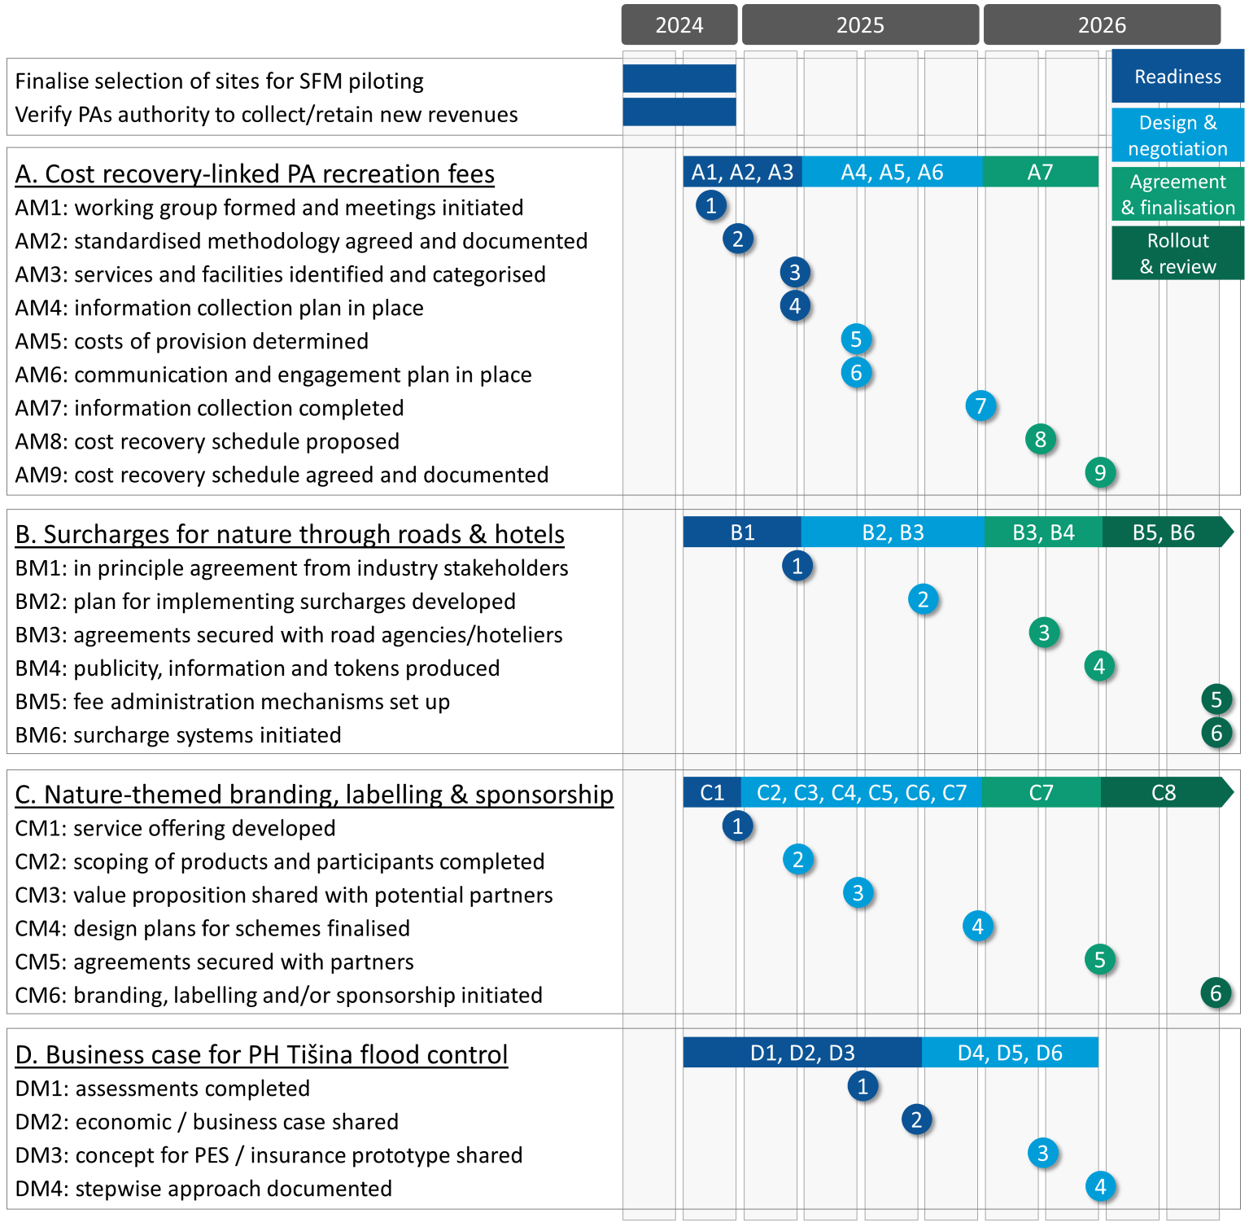

Five main groups of participants are involved in rolling out the pilot SFMs and delivering these milestones. These are: the target PAs, PA founders and Ministries of Finance, UNDP, technical experts, and SFM implementing partners. Each has different roles and responsibilities as regards developing, approving, planning and implementing each finance mechanism (Figure 5).

Figure 5: Key participants, roles and responsibilities in delivering milestones
 | Target PAs | PA founders &  Ministries of Finance | UNDP | Technical experts | SFM implementing partners
Finalise selection of sites for SFM piloting | - Express interest  - Commit to participate | - Endorse and approve | Lead planning process and documentation
Verify PAs authority to collect/retain new revenues | - Express interest  - Commit to participate | - Endorse and approve | Lead planning process and documentation
Cost recovery-linked PA recreation fees
AM1 working group formed and meetings initiated | - Participate in working group | - Participate in working group | Lead on establishing group, developing ToR, convening and reporting on meetings | - Participate in meetings as requested | - Participate in meetings as requested
AM2 standardised methodology agreed and documented | Lead on preparing plans and schedules for each PA | - Advise | - Coordinate and support  - Facilitate technical inputs  - Assist in organising dialogues and consultations with external partners  - Assist in documentation and information-sharing | - Assist and advise as requested
AM3 services and facilities identified and categorised
AM4 information collection plan in place
AM5 costs of provision determined
AM6 communication and engagement plan in place |  |  |  |  | - Participate in dialogues  - Contribute information and comments  - Agree to proposed schedules
AM7 information collection completed
AM8 cost recovery schedule proposed | Lead on developing draft schedule
AM9 cost recovery schedule agreed and documented | Lead on presenting for approval | - Endorse and approve | - Assist in documentation and information-sharing
Surcharges for nature through road tolls & bednight levies
BM1 in principle agreement from industry stakeholders | Lead on outreach and dialogue with industry stakeholders | - Participate in meetings as required | - Coordinate and support  - Assist in organising dialogues and consultations with external partners  - Facilitate technical inputs  - Assist in documentation and information-sharing |  | - Participate in consultations  - Agree to participate
BM2 plan for implementing surcharges developed | Lead on developing plan | - Advise  - Endorse and approve |  | - Assist and advise as requested | - Participate in dialogues  - Contribute information and comments
BM3 agreements secured with road agencies/hoteliers | Lead on negotiating agreements, signing agreements | - Advise  - Endorse and approve |  |  | - Sign agreements
BM4 publicity, information and tokens produced | Lead on designing and producing materials | - Advise  - Endorse and approve
BM5 fee administration mechanisms set up | Lead on setting up mechanisms | - Advise  - Endorse and approve |  | - Assist and advise as requested
BM6 surcharge systems initiated | Lead on setting up systems | - Advise  - Endorse and approve |  |  | - Participate in piloting
Nature-themed branding, labelling & sponsorship
CM1 service offering developed | Lead on developing offering | - Advise  - Endorse and approve | - Coordinate and support  - Assist in organising dialogues and consultations with external partners  - Facilitate technical inputs  - Assist in documentation and information-sharing | - Assist and advise as requested
CM2 scoping of products and participants completed | Lead on scoping | - Advise  - Endorse and approve |  | - Assist and advise as requested
CM3 value proposition shared with potential partners | Lead on developing and sharing value proposition | - Advise  - Endorse and approve |  | - Assist and advise as requested | - Participate in consultations  - Agree to participate
CM4 design plans for schemes finalised | Lead on planning process | - Advise  - Endorse and approve |  | - Assist and advise as requested | - Participate in dialogues  - Contribute information and comments
CM5 agreements secured with partners | Lead on negotiating agreements, signing agreements | - Advise  - Endorse and approve |  |  | - Sign agreements
CM6 branding, labelling and/or sponsorship initiated | Lead on setting up mechanisms | - Advise  - Endorse and approve |  |  | - Participate in piloting
Business case for flood control payments to PH Tišina
DM1 assessments completed | - Endorse approach and outputs  - Advise and comment  - Provide technical and strategic inputs | - Advise and comment | Lead on coordinating and overseeing studies, engaging and overseeing technical inputs, producing and sharing documentation, identifying and convening meetings with external partners, supporting PH Tišina in outreach to potential funders and implementing partners to further develop SFM | - Carry out studies
DM2 economic / business case shared |  | - Advise and comment |  | - Assist in developing business case | - Participate in consultations  - Indicate interest in partnering to further develop SFM
DM3 concept for PES / insurance prototype shared |  | - Advise and comment |  | - Assist in developing concept
DM4 stepwise approach documented |  | - Advise and comment |  | - Assist in documenting appraoch

References
Bankova-Todorova, M. and Y. Grigorova (2014) Market payments for wetland restoration in Persina Nature Park. WWF Danube-Carpathian Programme, Sofia.
Bankova-Todorova, M., Martini, M., Lucius, I., Grigorova, Y. and J. Tresierra (2013) Lessons learnt from testing payments for ecosystem services in the Lower Danube Basin. WWF Danube-Carpathian Programme, Sofia.
Beck, M., Quast, O. and K. Pfliegner (2019) Ecosystem-based Adaptation and Insurance: Success, Challenges and Opportunities. Joint report of the InsuResilience Global Partnership, ACRI+ and GIZ, Bonn.
Binet, T., Siazabakana, A. and N. Keurmeur (2016) Economic valuation of the Karaburun-Sazan Marine and Coastal Protected Area. United Nations Development Programme (UNDP), Tirana.
City of Boulder (2024) Boulder Parks and Recreation Fee Policy. Boulder, CO.
ClearSource (2022) Pleasant Valley Recreation & Park District Parks and Recreation Fee Based Cost Recovery Policy Development. ClearSource Financial Consulting, Aptos, CA.
CNVP (2013) Study and Analysis of Innovative Financing for Sustainable Forest Management in the Southwest Balkans. Connecting Natural Values & People (CNVP) Consortium: NRS Kosovo, REGEA Croatia, Diava Consulting, Albania, Faculty Forestry, Macedonia and Wageningen University, The Netherlands.
Emerton, L., Kaludjerovic J. and I. Jovetic (2011) The economic value of protected areas in Montenegro. GEF/UNDP PIMS 4279: Catalyzing Financial Sustainability of Protected Areas in Montenegro, Podgorica.
Flores, M. and I. Ivicic (2011) Valuation of the Contribution of the Ecosystems of Northern Velebit National Park and Velebit Nature Park to Economic Growth and Human Wellbeing: Croatia. WWF Protected Areas for a Living Planet ‐ Dinaric Arc Ecoregion Project, Zagreb.
GAO (2015) National Park Service. Revenues from Fees and Donations Increased, but Some Enhancements Are Needed to Continue This Trend. Report to Congressional Requesters, United States Government Accountability Office (GAO), Washington DC.
Ilieva, L., Bojovic, D. and C. Giupponi (2016) Framework proposal for development and implementation of Payments for Ecosystem Services scheme at Dojran Lake in Macedonia. Euro-Mediterranean Centre on Climate Change (CMCC), Lecce.
Kiš, A. and N. Stojnić (2018) Advocating ESAV in Bosut Forest Area: integrating biodiversity and ecosystem services in natural resource management. Case Study for GIZ Open Regional Fund for South-East Europe – Biodiversity (ORF BD) sub-project ‘Ecosystem Services and Valuation (ESAV) in Future Course of Action in South-East Europe Region, prepared by Institute for Nature Conservation of Vojvodina Province, Novi Sad.
LeRoy, S. and K. Green (2005) Can Markets Save Canada’s National Parks? Fraser Institute Digital Publication, The Fraser Institute, Vancouver.
Swiss Re Institute (2020) Biodiversity and Ecosystem Services. A business case for re/insurance Swiss Re Institute, Zurich.
TNC (2019) Investing in Nature: Private finance for nature-based resilience. The Nature Conservancy (TNC), Arlington.
World Bank (2022) Insuring Nature’s Survival: The Role of Insurance in Meeting the Financial Need to Preserve Biodiversity. The World Bank, Washington DC.

NP Una, NM Prokosko Jezero, NM Vrelo Bosne, PN Blidinje, and PL Vjetrenica.
NP Kozara, NP Sutjeska, NP Drina, PH Tišina. PN Una and PN Orjen.

